REQUEST FOR PROPOSAL
WELL DEEPENING AND REHABILITATION SERVICES FOR DOMESTIC WELLS
NOTICE TO PROPOSERS / PROPOSAL SUBMITTAL INSTRUCTIONS

1. DUE DATE AND TIME

Proposals for Well Deepening and Rehabilitation Services, as described herein, will be received by the City until April 13, 2023 at 3:00 pm. Proposals are to be submitted electronically. Submittal Instructions are provided below in Item 5.

Any changes to this RFP are invalid unless specifically modified by the City and issued as a separate addendum document. Should there be any question as to changes to the content of this document; the City’s copy shall prevail. It is the Proposer’s sole responsibility to ensure that their proposal, inclusive of any or all addenda, is received by the City at the stated time and place. Any proposal received after the scheduled closing time for receipt of proposals will not be considered and will remain unopened.

2. PROJECT OVERVIEW AND SCOPE OF WORK

The City of Dorris is currently seeking proposals from qualified well drillers to complete the following services.
- Either deepen two existing wells, or drill and install two new wells. The minimum number of wells to either be deepened or drilled is two; however, additional work will be completed as project budget allows.
- Install meters on new wells (as needed).

The Butte Valley Emergency Drought Relief Project is a multi-year effort to improve drought resiliency through a well deepening and water delivery program in the Butte Valley Watershed. The City of Dorris has received grant funding from the California Department of Water Resources for the Butte Valley Emergency Drought Relief Project to provide well deepening and/or rehabilitation services for two domestic wells or drilling and replacing two domestic wells. The wells to be serviced will be identified through a well outage survey of domestic wells in Butte Valley that is currently being conducted.

The candidate wells will be located close enough to the Butte Valley Irrigation District and Cities of McDoel, Mt. Hebron and Dorris, as shown in Figure 1 to provide service. All candidates must hold a California C-57 license and any other license approved by the California State Contractor's License Board for work described herein (e.g., D-21 license for well maintenance and rehabilitation). Candidates must also have workers compensation insurance, and general liability insurance. The selected contractor shall obtain all necessary permits to perform the work under this contract.,

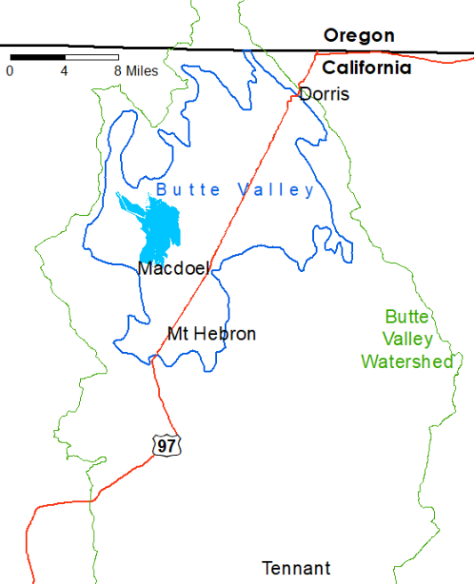
Figure 1. Project Area

Specific Tasks Include:

Task 1 – Planning, Design and Engineering
Develop plans and specifications to either deepen and retrofit two nearby wells, or drill two new wells. Wells will be rehabilitated if possible, and upgraded with new hardware and plumbing. Work to deepen or retrofit wells may include drilling to increase well depth, well casing installation and gravel packing, increasing the length of the existing screen or replacement of the existing screen, well pumping repair or replacement, well disinfection activities, well development and test pumping, and site cleanup. In instances where replacement wells are needed, the old wells will need to be properly abandoned under permit. In instances where a new well will be installed, the design shall identify the well construction method, drilling depth, diameter, and anticipated flow rate. Typical domestic well depth in Butte Valley is under 100 feet below ground surface, however historical records indicate completed wells in competent volcanic, fractured volcanic, alluvial sediment, and lake sediment. In both instances of retrofitting an old well or installing a new well, the finished wells should be equipped with water level meters and flow meters.

Install wells with water level meters and flow meters.

Deliverables:
- All design documents
- 50%, 90%, and 100% plans and specifications
- Well completion report

Task 2 – Construction
The contractor shall provide all necessary equipment and personnel to complete the job. Project sites will be located in the area of the Butte Valley Irrigation District, and cities of McDoel, Mt. Hebron and Dorris.

3. GENERAL INFORMATION

The City will select a qualified firm to perform the required services generally based upon their
qualified expertise, project understanding, and price in accordance with the requirements
set forth within this Request for Proposal.

The City's intent is to enter into an agreement with a single contractor for the provision of these services on an as-needed basis. All performance pursuant to this agreement shall be on an "on-call" or "as-needed" basis. Any tasking shall be initiated solely by the City. Further, execution of an agreement by the City does not in any way guarantee that any tasking or request for on-call services will be issued to any party. Moreover, execution of an agreement by the City shall not entitle the other party to any form of payment or compensation from the City without first having issued tasking or request for services from the contractor.

All work and general conditions shall be performed in accordance with the current Standard Specifications for Public Works Construction (the Green Book), the State Water Resource Control Board (SWRCB), the American Water Works Association (AWWA) Standards, and the National Electrical Manufacturers Association (NEMA) Standards.

The proposer may utilize the services of specialty subcontractors on those parts of the work that, under normal contracting practices, are performed by specialty subcontractor. It is understood that at least 50 percent of the work to be performed shall be performed by the successful contractor. Any subcontractor used must adhere to the same terms and conditions as the successful contractor. The proposer and any subcontractor must have all appropriate licenses, certifications, and registrations to perform the work hereunder.

The proposer shall be fully responsible to the City for the performance of his/her subcontractors, and of persons either directly or indirectly employed by them.

Bidder's Security shall be in the amount of 10% of the amount of the Bid. The successful Bidder will be required to furnish a Labor and Material Bond and a Faithful Performance Bond, each in the Amount of 100% of the Contract Price, in the form and time set forth in the Contract Documents.

4. REQUESTED INFORMATION

Applicants are requested to provide the following information.

- A cover letter including:
- Company name
- Address
- Full contact information
- Brief description of the company
- Identification of partner firms (if applicable)
- License number and other relevant certifications
- Brief history of the firm’s safety record
- Signature of authorized representative of the firm
- Qualifications:
  - Brief list of similar projects completed by the firm
  - Please include 2 references with contact person and contact information
- Cost and Schedule:
  - Please provide your firm’s estimated costs to drill and install a domestic well. An example domestic well in Butte Valley is likely 90 feet in depth, completed through 60 feet of alluvial deposits and 30 feet of competent volcanic rock. Please include the assumptions incorporated into the cost estimate including the well depth, casing and screen specifications, pump and equipment to be installed, as well as equipment used to complete the job.
  - Please provide a standard timeline for your firm to conduct the domestic well installation described above.

5. INSTRUCTIONS FOR PROPOSAL SUBMISSION

Due Date: No later than 3:00 p.m., PST, on April 13, 2023
Email To: cityadmin@cot.net
Email Subject: RFP Submittal for Well Deepening and Rehabilitation Services.”

Questions regarding this proposal should be submitted to

Betsy Elzufon
Larry Walker Associates*
530-753-6400x227
betsye@lwa.com
*LWA is assisting the City with this project

Proposals should be submitted electronically to the above email address and include the subject line shown above. Late proposals will not be accepted. Proposals will not be publicly opened. Incomplete proposals will not be considered.

6. CONTRACTOR SELECTION CRITERIA

All responsive proposals will be considered, and each will be evaluated to ascertain which one best meets the needs of the City. Additional requests for information may be necessary to clarify parts of the proposal. Evaluation criteria will include the following:
1. Experience and Qualifications of the contractor in general as well as the project manager and other key individuals. Provided licenses and good safety record.
2. Capability to perform necessary tasks, timeliness of installation and/or repairs, and maintain a full-service shop with all necessary equipment required for well and pump repair and rehabilitation projects
3. References and overall quality of proposal including compliance with proposal requirements.
4. Schedule

Term of Agreement. The anticipated start date for the new agreement is June 1, 2023 and the anticipated agreement term is one (1) year.

Required Licenses. The successful Contractor and any subcontractor(s) must possess a current and valid California Contractor State Licensing Board (CSLB) license(s) in the classification(s) required by law to perform the work. For this project, Contractor must possess a current California C-57 license and a D-21 licenses as needed for maintenance and rehabilitation tasks as needed.

